GISMA UNIVERSITY OF APPLIED SCIENCES


TITLE
BUILDING DEEP LEARINING MODELS (LSTM & TRANSFORMER) AND STATISTICAL MODEL (FACEBOOK PROPHET) TO PREDICT WEATHER TEMPERATURE FOR THE NEXT 7 DAYS IN BERLIN: COMPARATIVE ANALYSIS OF THEIR PERFORMANCE USING OPEN-METEO API HISTORICAL DAILY WEATHER DATA

BY:
Theophilus Otoo

A Dissertation Submitted in Partial Fulfillment of the Requirements for the Degree of Master of Science in Data Science, AI and Digital Business.
Department of Computer Science.

Table of Content
Chapter 1: Introduction 3
1.1 Introduction 3
1.2 Problem Statement 6
1.3 Research Objective: 7
1.4 Research Questions: 8
1.5 SIGNIFICANCES OF THE STUDY 8
1.6 Scope and Limitations 8
1.7 Dissertation Structure 10
CHAPTER 2: 10
2.1. LITERATURE REVIEW 10
2.2 RELATED WORKS 11
2. 3 Key Models Relevant to This Study 14
2.3.1 Long Short-Term Memory (LSTM) 15
2.3.2 TRANSFORMER 18
2.3.3 PROPHET MODEL 19
2.4 Research Gap 21
CHAPTER 3: METHODOLOGY 22
3.1 Introduction 22
3.2 Methodology and Research Design 22
3.3 Description of the Forecasting Zone (Berlin) 23
3.4 Data Source: Open-Meteo API historical daily weather data. 24
CHAPTER 4: RESULTS 32
4.1 Introduction 32
4.2 Data Characteristics 32
4.2.1 CORRELATION ANALYSIS 33
4.3 HYPERPARAMETER TUNING RESULTS 35
4.3.1 Bi-LSTM hyperparameter Search 35
4.3.2. Transformer Hyperparameter Search 36
4.3.3 Prophet Hyperparameter search 37
4.4 MODEL DEVELOPMENTS 38
4.4.1 LSTM (Bidirectional) Model Development 38
4.4.2 Transformer Model Development 39
4.4.3 Prophet Model Development 39
REFERENCES 42

Chapter 1: Introduction

1.1 Introduction
Temperature forecasting is the process of predicting future temperature values based on historical data. It is a valuable tool that can be used to improve decision-making in a variety of sectors (Sardans, J., et al., 2006).
The integration of artificial intelligence (AI) and deep learning (DL) presents significant opportunities for predicting meteorological variables such as temperature (Fister, D., et al., 2023).
Forecasting weather is an integral area of science and technology that is usually under-appreciated. The ability to predict the behaviour of the atmosphere in the next few days is of significance to everyone. Whether a person needs a forecast to plan farming and water management, an energy operator to ensure that the balance between supply from wind and solar power sources is appropriate, or a healthcare professional for adequate preparedness to cope with the upcoming hot period, the timely provision of accurate local data becomes vital (Nagaraj and Kumar, 2023). Therefore, weather forecasting goes beyond technical concerns and becomes the public good, whose failures might lead to negative consequences such as food shortages, instability in energy supplies, deterioration of infrastructure, and even loss of lives. As a result, there appears to be a demand for accurate weather forecasts as not only a scientific need but as a practical requirement for the work of businesses, countries, and societies all over the world.
Numerical weather predictions have traditionally served as a solution to the existing demand for weather forecasts. According to this technique, the state of the atmosphere is described with the use of mathematical grids where the systems of partial differential equations describing fluid dynamics, thermodynamics, and radiation within the atmosphere operate. Over several decades, numerical weather prediction techniques have been developed and implemented by meteorological organisations at the national and international level (Wu and Xue, 2024). There are numerous state-of-the-art techniques producing valuable predictions for medium-range guidance globally, although their effectiveness has improved considerably with time. However, all the systems rely upon certain assumptions and resources that make them inaccessible to many stakeholders. It takes significant computing power to generate a full numerical prediction, which necessitates constant data assimilation and professional expertise (Brahmane et al., 2025; Bi et al., 2023). This means that while national organisations can rely on high-resolution models, academic groups, regional planners, and decision-makers will have to rely on coarse-gridded forecasts in cases where no relevant data are available.
Apart from being hampered by concerns related to access, numerical weather predictions are limited by an intrinsic physical limitation, which cannot be mitigated fully regardless of technological advancements.
Weather is a chaotic system, where tiny errors in initial state conditions of the model grow and amplify throughout time periods. As a result, numerical forecasts become less precise with every day forecast extension, and the decline occurs faster than four or five days into predictions (Bach, Crisan, and Ghil, 2025). Hence, the seven-day forecast period becomes the limit where physically-based predictions lose their relevance and fall into the grey area between possible and impossible. In other words, the seven-day horizon represents an interesting point where accurate predictions can be done, but such tasks prove extremely hard.
Due to limitations inherent to numerical predictions, the application of machine learning algorithms gained traction as an alternative technique for producing forecasts. The principle behind machine learning algorithms is in avoiding the need for atmospheric physics equations since they only recognise patterns and predict them. Machine learning algorithms are capable of competing with physically-based forecasting systems in terms of precision and require fewer computational resources (Ben Bouallegue et al., 2024). With large-scale forecasting becoming viable thanks to data-driven models, many entities incapable of maintaining expensive infrastructures can use such systems for forecasting. Thus, there are no limits to where machine learning-based forecasts can be applied and used productively (Price et al., 2025).
This study addresses a particular problem of producing forecasts on a seven-day horizon for daily temperature in Berlin. Such horizon proves useful due to its relevance and appropriateness to produce actionable forecasts: long enough to allow decision making and short enough for machine learning models to recognise a reliable pattern in the past (Ahajjam, Putkonen, Chukwuemeka, Chance, and Pasch, 2024). Temperature has a direct effect on people's life, affecting energy consumption, crop yield, health risks, among others. Therefore, the ability to predict it correctly can contribute significantly to improving people's life.
Deep learning has emerged as one of the most promising technologies for time-series forecasting. Unlike conventional machine learning algorithms, deep learning models can automatically extract meaningful features from large datasets and model intricate temporal relationships. Among these models, Long Short-Term Memory (LSTM) networks have gained significant popularity because of their ability to capture long-term dependencies in sequential data (Hochreiter and Schmidhuber, 1997). LSTM networks address the vanishing gradient problem commonly encountered in traditional recurrent neural networks, making them suitable for weather prediction tasks.
More recently, Transformer architecture has attracted considerable attention in sequence modelling applications. Originally developed for natural language processing, Transformers employ self-attention mechanisms that enable the model to focus on relevant information across entire sequences simultaneously rather than processing observations sequentially (Vaswani et al., 2017). This capability has demonstrated significant advantages in various forecasting applications, including climate and weather prediction.
Berlin, the capital city of Germany, experiences a temperate seasonal climate characterized by significant variations in temperature throughout the year. Accurate forecasting of temperature in Berlin is important for urban planning, energy demand management, transportation systems, and public health initiatives. Historical meteorological data collected from weather stations provide an opportunity to investigate the effectiveness of modern deep learning approaches in forecasting future temperature patterns.
This study focuses on building three models (LSTM, Transformer and Facebook Prophet) to predict daily temperatures for the next seven days in Berlin as well as comparing their performances. By evaluating the performance of these models using historical meteorological data, the study aims to identify the most effective architecture for the seven (7) day temperature prediction for Berlin.

1.2 Problem Statement
Weather is a continuous, multidimensional, dynamic, and chaotic process, which makes weather forecasting a tremendous challenge (Thi Kieu Tran, T., et al., (2020). Forecasting daily temperature has been a great challenge that the meteorological department faces today. a great. Temperature forecasting is a progressive and time series analysis process to forecast the state of the temperature for a certain location. Time series forecasting of meteorological variables such as daily temperature has recently drawn considerable attention from researchers to address the limitations of traditional forecasting models (Thi Kieu Tran, T., et al., 2020).
Weather monitoring and forecasting are essential for many purposes, such as avoiding flight disruptions (Gultepe et al. 2019), optimizing agricultural productivity (Cogato et al. 2019), and managing energy supply and demand (Liu et al. 2018; Kim et al. 2020). Moreover, climate change and global warming have increased the occurrence of extreme weather events, which require more quantitative approaches to understand and mitigate their effects (Wanishsakpong & Owusu 2020).
Over the years, numerical weather prediction techniques have been developed and implemented by meteorological organisations at the national and international level (Wu and Xue, 2024). Due to limitations inherent to numerical predictions, the application of machine learning algorithms and deep learning gained traction as an alternative technique for forecasting because of their ability to learn complex temporal relationships directly from historical weather observations.
Deep learning (DL) has revolutionized the field of artificial intelligence in recent years, resulting in state-of-the-art performance on a variety of tasks (Al-lQubaydhi et al., 2024; Li et al., 2024).
Deep learning has emerged as one of the most promising technologies for time-series forecasting.
Among these techniques, the Long Short-Term Memory (LSTM) network has been specifically designed to address the issue of vanishing gradients (Jaydip and Sidra, 2022). Additionally, Transformer architecture also emerged as powerful alternative technique for forecasting because of its ability to use self-attention mechanisms to focus on important parts of the sequence efficiently (Vaswani et al. 2017). Also, Facebook Prophet is a modular regression model for time series predictions with high accuracy by using simple interpretable parameters that consider the effect of custom seasonality and holidays. (Oo, Z. Z., & Phyu, S. ,2020).
Despite the increasing popularity of these models in weather forecasting, there remains limited empirical evidence comparing LSTM, Transformer, and Prophet models for short-term (7-day) weather temperature prediction using historical daily weather data obtained from the Open-Meteo API, particularly for Berlin, Germany. Most existing literatures compare deep learning models with traditional statistical methods such as ARIMA or focus on hybrid architectures rather than evaluating the forecasting capability of Transformer, LSTM, and Prophet models under identical experimental conditions.
In conclusion, this study seeks to build LSTM, Transformer, and Prophet models using Open-Meteo API historical daily weather data to predict daily mean weather temperature for the next seven (7) days in Berlin, Germany. The study will also compare the predictive performance of all the three models using standard evaluation metrics such as Root Mean Square Error (RMSE), Mean Absolute Error (MAE), Mean Absolute Percentage Error (MAPE), and Coefficient of determination (R²). The findings will help in identifying the best predicting model suitable for the next seven (7) days temperature forecasting for Berlin, hence contributing to the growing body of knowledge in weather temperature forecasting systems.

1.3 Research Objective:
The objective of the study is divided into General objective and Specific objectives.
General Objective:
The general objective of the research is to build and compare three different models (LSTM, Transformer, and Facebook Prophet) in predicting weather temperature for Berlin using Open-Meteo API historical daily weather data.
Specific Objectives:
Based on the general objective of the study, the following specific objectives were set
- To collect and process historical weather data for the city of Berlin using the Open-Meteo API historical daily weather data.
- To build and train deep learning models (LSTM and Transformer) and Statistical model (Prophet) capable of predicting daily temperature for the next 7 days in Berlin.
- To evaluate and compare the three (3) models performance across the Berlin city in Germany.
- To identify which model performs best for predicting short-term weather temperature.

1.4 Research Questions:
- Can we accurately forecast temperature using past weather patterns? Can temperature be forecasted accurately using historical weather patterns?
- How do deep learning models (LSTM, Transformer) compare against a statistical model (Prophet)?
- Does hyperparameter tuning significantly improve deep learning accuracy?
- What is the prediction accuracy for short-term (7-day) temperature forecasting?

1.5 SIGNIFICANCES OF THE STUDY

1.6 Scope and Limitations
One of the primary limitations of this study is that the dataset used for temperature prediction is an open-source obtained from Open-Meteo API historical weather data spanning the period from June 17, 2024, to June 17, 2026. The data from this source is free to access, it does not require API key, provides historical and forecast weather data. Additionally, regarding the geographical scope, the chosen city under consideration is Berlin ((52.52°N, 13.405°E), the capital of Germany which will represent unique Koppen climatic type. While the dataset provides a comprehensive and structured representation of temperature variations within the region (Berlin, Germany - 52.52°N, 13.405°E), its geographic specificity may limit the generalizability of the findings to other climates and geographical conditions (Kişmiroğlu, C., & Isik, O. (2025). Also, the duration for the forecasting is specified to be seven (7) days and the proposed models employed for this forecasting include Bi-LSTM, Transformer and Facebook Prophet.
This paper focuses on building three algorithms including Long Short-Term Memory (LSTM), Transformer and Facebook Prophet to predict temperature for the next 7 days in Berlin-Germany. Forecasting air temperature is an important part of weather prediction because it is used to protect human lives and properties. People may suffer potential health problems when the air temperature is not in a suitable range (Lan, L.; Lian, Z.; Pan, L, 2010; Schulte, P.A.; Bhattacharya, A.; Butler, C.R.; Chun, H.K.; Jacklitsch, B.; Jacobs, T.; Kiefer, M.; Lincoln, J.; Pendergrass, S.; Shire, J.; et al., 2016). Extreme changes in air temperature may cause damage to plants and animals. The accurate forecast of air temperature is essential due to its significant effect on various sectors, such industry, energy and agriculture. (Sharma, N.; Sharma, P.; Irwin, D.; Shenoy, P, 2011; & Sardans, J.; Peñuelas, J.; Estiarte, M, 2006).
Therefore, accurate temperature forecasting for the next seven-days in Berlin, Germany will help Government, policy makers, institutions to come up with safety precautional measures to help protect human lives and properties.
Secondly, the study aims to fill the research gap since there are limited literature or studies exist for temperature predictions in temperate zones like Berlin city where LSTM, Transformer and Facebook Prophet models have been used simultaneously to predict temperature for the next 7 days using the Open-Meteo API dataset. This will give valuable insight and future research directions to researchers who are interested in conducting research in this area, applying these three models (LSTM, Transformer and Facebook Prophet) at the same time.
Finally, the proposed temperature prediction models employed for this study will help meteorologists to better estimate weather in future for a specific location (Oo, Z. Z., & Phyu, S. (2020). Though there are many machine learning and deep learning models used for temperature forecasting. However, this study is limited to Bi-LSTM, Transformer and Facebook Prophet models.

1.7 Dissertation Structure
Chapter two is devoted to explaining the theoretical and practical background of the study, which covers the basic principles of weather forecasting, existing techniques, deep learning applications for time series, model selection, climate region, and relevant literature. In chapter three, the methodology section will be discussed. It will include information on data gathering, pre-processing, feature engineering, models development, and evaluation strategy. The results are presented in chapter four. Chapter five discusses the interpretations of the key findings. The final chapter (six) outlines the conclusions and recommendations. The dataset adopted for this study is a public source data obtained from Open-Meteo API historical daily weather data for Berlin, Germany with a geographical coordinate of Latitude 52.5200°N and longitude 13.4050°E.

CHAPTER 2:

2.1. LITERATURE REVIEW
Temperature forecasting is a progressive and time series analysis process to forecast the state of the temperature for a certain location in the coming time. Nowadays, agriculture and manufacturing sectors are mostly dependent on temperature so forecasting is important to be precise because temperature warnings can save life and property. (Oo, Z. Z., & Phyu, S. (2020).
A time series is a collection of data points fixed in time. Time series analysis is applied to analyze these time series data by combining different methods to obtain meaningful information. The forecasting of the time series data is a methodology which can help the model predict future values using previously observed historic values (R. Adhikari and R. K. Agrawal, 2013).
Prediction of air temperature is very valuable for some communities and occasions. Therefore, high accuracy prediction is needed. Since the information about air temperature might vary over time, it is necessary to implement methods that can adapt to this situation. The use of neural network methods such as long short-term memory (LSTM), nowadays, has become popular in facing big data including unexpected fluctuation in the data. In addition, recently, Facebook announced an accurate method of forecasting, called Prophet model, for data which have trend, seasonality, holidays, missing data, not to mention outliers (Toharudin et al., 2021).

2.2 RELATED WORKS
Malakouti (2023) used ANN to predict average air temperature for smart agriculture. The results show that the method can be used in smart agriculture to predict temperatures with fewer errors than those achieved with traditional approaches. Tran et al., (2020) optimized the hyperparameters of the ANN, LSTM, and RNN models using genetic algorithms and applied these models at Cheongju station in South Korea to calculate the maximum temperature prediction. Abhishek et al., (2012) forecasted the maximum daily air temperature of a station area between 1999 and 2009 using a feed-forward neural network. The input data used consists of the maximum air temperature for the last 10 years. According to the calculations, it was determined that the ANN with the tan-sigmoid transfer function made the best maximum temperature predictions. Qui et al. (2021) used deep learning methods for river water temperature prediction. In their study, they estimated daily river water temperatures using the LSTM method. They stated that the results of the method gave more accurate results than other methods in forecasting the average daily water temperature in rivers. Wei and Du (2010) introduced a temperature forecasting approach utilizing the autoregressive moving average (ARIMA) model to mitigate the risk of insulated gate bipolar transistor (IGBT) module failures and enhance their operational efficiency. The autoregressive model is constructed using historical and current temperature data to estimate the temperature trends in IGBT chips. Zang et al. (2021) proposed a temperature forecasting model using urban temperature data and a LSTM network. The model, implemented with TENSORFLOW, leverages past temperature data to forecast future temperature values. The LSTM neural network was tested using temperature data from the city of Vilnius and subsequently employed to predict future sequences with varying lengths, including both single-step and multi-step predictions.
Kreuzer et al. (2020) used the convolutional long short-term memory (convLSTM) method to forecast air temperature up to 24 h in advance in five weather stations of Germany during 2009 –2018. They compared the performance of convLSTM with those of the seasonal autoregressive integrated moving average (SARIMA), seasonal naive approach, and univariate and multivariate LSTMs. Hourly air temperature, relative humidity, cloud coverage, precipitation, wind speed and direction, month of year, hour of day, sea-level air pressure, and the difference between the air pressure at the station and the sea level were used as inputs in multivariate LSTM and ConvLSTM. They showed that the seasonal naive approach has the worst performance for most of the prediction horizons. While the SARIMA and univariate LSTM network performed well for the first two- to three-hour air forecasts, the ConvLSTM and multivariate LSTM showed a better performance for longer forecast horizons. In the stations with large variations of air temperature during the day, convLSTM outperformed other methods.
Lee et al., (2020) employed three neural network models (namely, MLP, LSTM, and CNN) to forecast the average, minimum, and maximum air temperatures for the next day in three regions of South Korea. They tried both hourly and daily air temperature, precipitation, humidity, vapor pressure, dew point temperature, atmospheric pressure, sea-level pressure, hours of sunshine, solar radiation, cloud cover, ground surface temperature, and wind speed and direction as inputs in the previous 30 days. Hourly input data provided better information for daily air temperature forecasting than daily input data. Overall, the CNN with hourly input data showed better performance than the MLP and LSTM.
In Oo & Phyu, (2020) research, Prophet was applied in metrological factors forecasting, such as temperature prediction. This project obtained the daily average temperature (2010 to 2017) from a local weather station in Myitkyina, Myanmar. Univariate time-series forecasting was implemented, where the annual temperature was forecasted for a year ahead. This model implemented a direct strategy, which predicts several steps for a defined time. The forecasting model successfully fitted the data, with an RMSE value of 5.75 (for 2012 and 2014). As the model demonstrated promising results, it can be concluded that the algorithm is reliable in forecasting meteorological data.
In Bandung, Indonesia, weather stations use numerical weather prediction (NWP) models to forecast temperature for a specific time horizon. However, (Toharudin et al., 2021) claim that this approach can only be used for exploratory purposes. Machine learning algorithms, such as Prophet and LSTM, were developed to provide more reliable forecasts. Temperature data from a local weather station (2014 to 2019) was retrieved to predict minimum and maximum temperatures. The RMSE values reveal that Prophet effectively forecasted the maximum temperature, while LSTM proved the same for minimum temperature. Taking the average RMSE, both showed similar performance in temperature prediction
In a similar approach, the Prophet algorithm was combined with LSTM in (Ma et al., 2022) to forecast the temperature in China. Ten years of metrological data starting from 2000 were used for building the model. The consolidated model began with filtering and normalizing the data to apply the LSTM algorithm. In parallel, Prophet was applied with logarithmic data inputs to produce forecasts. Together, the outputs of each model were combined in a processing step to determine their corresponding weighted averages. Tuning of the weighted averages was performed to optimize the forecasts further. Forecasts of the hybrid model recorded a low RMSE error of 2.49. In comparison, the individual models recorded 3.26 using Prophet and 2.5 using LSTM for the same metrics
Furthermore, (Jagannathan & Divya, 2021) forecasted a year ahead temperature by modeling the Prophet algorithm. For Chennai, India, the developed model used temperature data (2008 to 2021) as training data. The study reported that the model outperformed other popular forecasting algorithms such as ARIMA, Auto-ARIMA, and LSTM, evidenced by an RMSE and accuracy value of 2.49 and 97.5%, respectively.
Collectively, these studies demonstrate the growing adoption of deep learning and statistical forecasting models in weather prediction. However, few studies provide a direct comparison of standalone LSTM, Transformer, and Prophet models for seven-day daily temperature forecasting using Open-Meteo historical weather data for Berlin. This thesis addresses that gap by implementing all three models under the same preprocessing pipeline, training procedure, forecasting horizon, and evaluation metrics.
Deep Learning in weather forecasting
Traditional machine learning methods rely on manually hand-crafted, domain-specific features to capture temporal dynamics. However, these techniques often concentrate on single variables, missing the interactions among them (Reichstein, M. et al., 2019).
In addition, manual feature selection carries risks of error and requires substantial domain expertise. Machine learning models also struggle with large-scale, high-dimensional data, often lacking generalization and being prone to overfitting (Zhang,J. et al., 2024).
Different deep learning architectures have been developed to accommodate the non-linearity of time series datasets in the weather forecasting domain.
Deep learning, however, employs multilayer neural networks that automatically identify complex nonlinear patterns and spatiotemporal dynamics, reducing the reliance on manual feature engineering (Yuan, Q. et al., 2020).
These methods are capable of identifying intricate patterns and achieving superior prediction accuracy and generalization across multiscale and complex environments (Hong, D. et al., 2023).
Therefore, deep learning methods are well-suited to process large-scale and high-dimensional weather data, and more and more researchers have paid attention to utilizing deep learning in Earth and atmospheric sciences.

2. 3 Key Models Relevant to This Study
Even though several models have been used to predict temperature in times past. However, this study focuses on building three time series models to predict temperature for the next seven (7) days for Berlin and compare their performances using Open-Meteo API historical daily weather dataset. The key models relevant to this study include two advanced deep learning architectures, two advanced deep learning architecture, (Bi-LSTM and Transformer) models and Facebook Prophet. These key models are discussed below:

2.3.1 Long Short-Term Memory (LSTM)
LSTM
Long Short-Term Memory Neural Networks are similar to RNN, which has the capability to learn larger data compared to normal RNNs. This is done by controlling the hidden state in LSTM and solving the vanishing gradient problem. LSTM has feedback connections. An LSTM unit has an input gate, an output gate, and a forget gate. LSTM calculates a gate’s value using the previous cell value Ct₋₁, previously hidden values ht₋₁, input x_{t} (Hochreiter & Schmidhuber 1997).
According to Olah, (2015) the key to LSTM is the hidden neurons in the LSTM layer called memory cells (LSTM cells), which not only receive information from the input layer but also perceive the information at the previous moment.

The formula for the LSTM layer can be expressed as follows (Olah 2015):
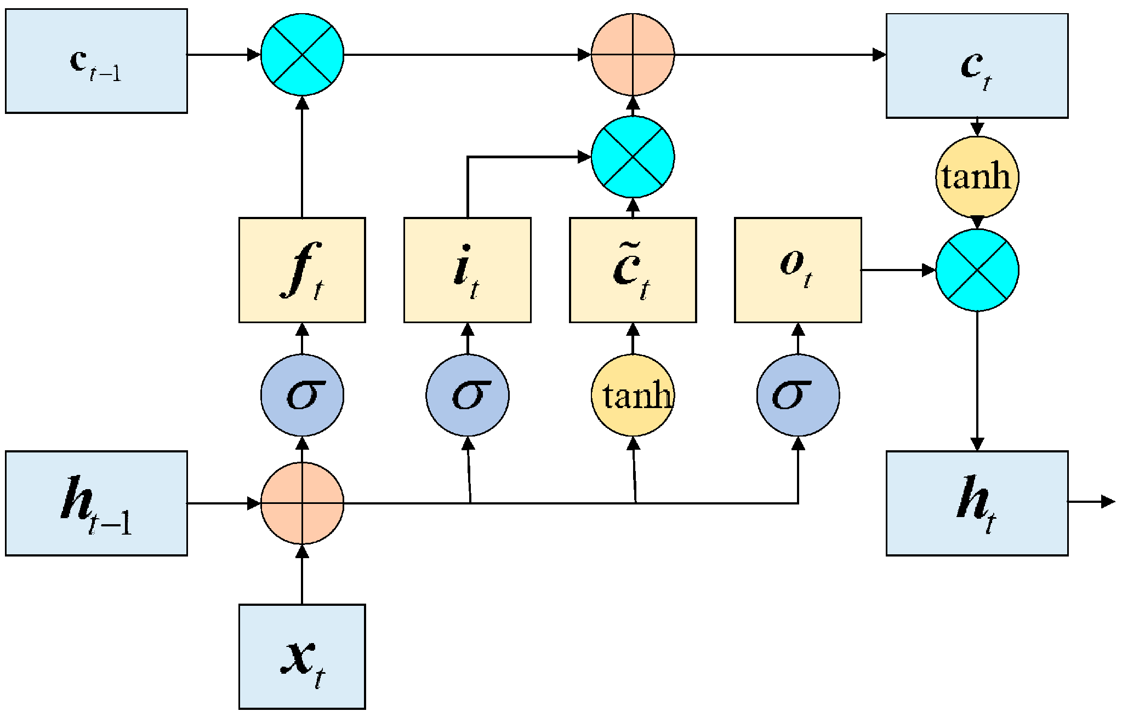
(Fig. 1 : The structure of LSTM Model (Zhang, Huo, & Shao, 2023))
From the above diagram, ${(f}_{t}$) represents the forget gate, ${(i}_{t,)}$ denotes the input gate, and the ($o_{t) }$ also represents the output gate. The ${ h}_{t-1}$ denotes the hidden state of the $t-1$moment. $x_{t}$represents the input at the $t$time. $c_{t}$represents the state of the cell at the current time. ${\tilde{c}}_{t }$is the candidate value vector. $σ$is the Sigmoid activation function (Zhang, Huo, & Shao, 2023).
LSTM is commonly adapted to time series algorithms. The input gate controls the extent to which new information should be written into the cell state, the forget gate uses an activation function to decide which values to update.
LSTM is like RNN, but by using the three gates, it can process longer lengths of data, and it is also able to solve the vanishing gradient problem (Maddu et al, 2021).
Since it’s introduction in 1997 by Hochreiter and Schmidhuber (1997), LSTMs have become widely used and highly effective in various sequential data tasks, from speech recognition to machine fault prediction. They have been shown to outperform other types of RNNs and traditional Machine Learning (ML) methods in several tasks
Zhang, Huo, and Shao, (2023) emphasised that the limitation of the LSTM network unit is that it can learn the data characteristics of the preorder component but cannot combine the data characteristics of the post-order component. However, the Bi-LSTM implements additional training by traversing the input data twice and can capture both forward and backward information. It consists of two different LSTM network hidden layers with the outputs located in opposite directions.
In this regard, this study focuses on building Bidirectional LSTM together with Transformer and FaceBook Prophet to predict the next seven (7) days temperature for Berlin, Germany.
Bidirectional LSTM (Bi-LSTM)
Schuster and Paliwal (1997) assert that Bidirectional LSTM (Bi-LSTM) is an extension of traditional LSTMs that can improve model performance on sequence classification problems. It consists of two LSTMs. That is, one LSTM is trained by sequential input data from the forward, and the other LSTM trains by taking data from backward direction. Doing this increases the amount of information available for classifying the data, improving the performance compared to a traditional LSTM.
Salehinejad et al. (2018) also claimed that this type of process is helpful in time series data when one wants to learn the data at each timestep.
Balakrishnan et al, (2022) emphasised that bi-directional network has the capacity to learn sequential patterns by considering the inputs from both the start and end implicit layers of the sequence which enables the exploration of connections between current data and previous as well as future moments, resulting in a more comprehensive analysis of inverse information, enhanced handling of long-term dependencies, and improved accuracy in model predictions.
Bidirectional Long Short-Term Memory (Bi-LSTM) is a special kind of Recurrent Neural Network (RNN) architecture which is designed to model sequences and their long-range dependencies more precisely than RNNs (Tavakoli, 2019).

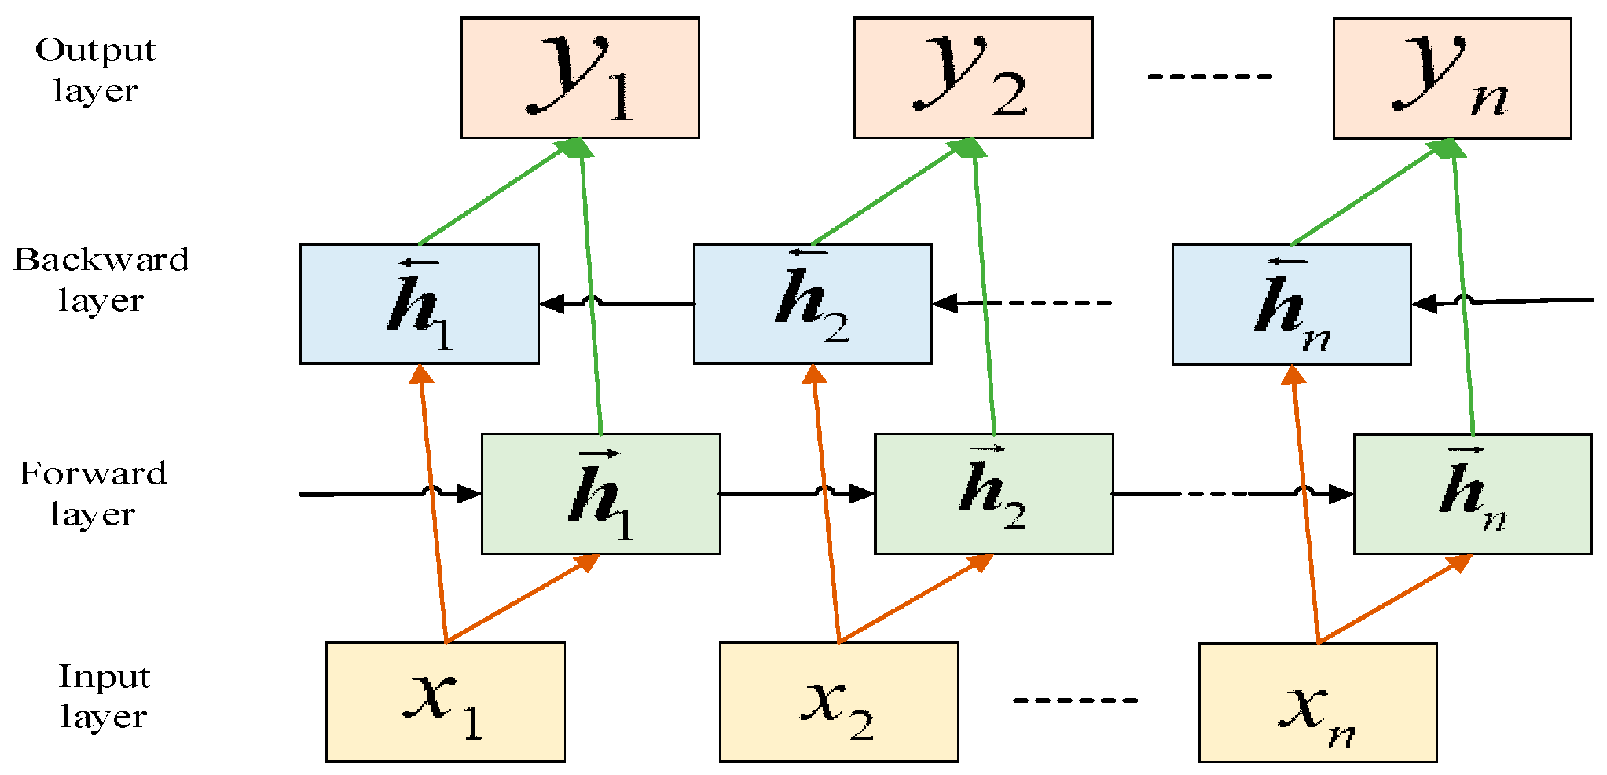
(Fig. 2 : The structure of LSTM Model (Zhang, Huo, & Shao, 2023))

2.3.2 TRANSFORMER
Transformer Models for Time-Series Forecasting.
The transformer-based model, introduced by (Vaswani et al. 2017), represents a significant advancement in AI, particularly in handling time and space complexity. This approach has garnered increasing interest from both academia and industry. Unlike traditional RNNs and LSTMs that rely on sequential dependencies, transformer models process input and output sequences in parallel, enabling the independent analysis of temperature and radiation time-series data [23].
Originally developed for natural language processing, transformer models have proven effective in time-series forecasting by capturing long-range dependencies and complex patterns.
Comparisons with traditional methods such as ARIMA and ETS demonstrate the transformer’s ability to capture both short- and long-term dependencies. The self-attention mechanism enhances adaptability and addresses issues such as the vanishing gradient problem. The transformer model fills gaps in existing research by improving long-term forecasting accuracy and managing nonlinear dynamics in weather data, proving its versatility in meteorological applications such as precipitation forecasting and climate modeling.

2.3.3 PROPHET MODEL
Facebook Prophet Model
This study employs Facebook Prophet, a time series forecasting model known for its robustness and simplicity. Prophet is a modular regression model for time series predictions with high accuracy by using simple interpretable parameters that consider the effect of custom seasonality and holidays. (Oo, Z. Z., & Phyu, S. ,2020).
Saeed et al, (2023) assert that Prophet is a forecasting algorithm or procedure developed by Facebook to create forecasting models for their in-house projects based on an additive model where non-linear trends are estimated with yearly, weekly, and daily seasonality, plus holiday effects. Prophet aims at producing accurate forecasting models which require minimal manual efforts and are robust to outliers, missing data, and changes in time series data. While having many automation features, Prophet simply uses a decomposable time series model such as the generalized additive model (GAM). Specifically, Prophet uses a generative model with three main components including trend, seasonality, and holidays or events.
To use Prophet for forecasting, one must first define and initialize a Prophet() object, then fit it to the training dataset using the fit() function and supply the prepared dataset. After fitting the model, we can use the predict() function to generate future forecasts. It's important to assess the model's performance by comparing the predictions to actual values, allowing for adjustments in the seasonal parameters if necessary. If the initial model does not perform satisfactorily, we may consider tuning hyperparameters or adding additional regressors to better capture the underlying trends and seasonality in the data. Continuous evaluation and refinement of the model can lead to improved forecasting accuracy and more reliable insights (Chhabra et al., 2024).
Atamimi, Witanti, and Abdillah (2025) claimed that there are several hyperparameters that can be tuned in Prophet, including changepoint prior scale, Seasonality Prior Scale, and Seasonality Mode, where the ChangePoint Prior scale is a parameter that determines the flexibility of the trend, specifically how much change is allowed at the changepoints. Higher values of this parameter result in a more flexible model that can adapt to trend shifts more easily. Conversely, lower values may cause the model to underfit, introducing noise due to insufficient sensitivity to trend changes. Additionally, the Seasonality Prior Scale controls the flexibility of the seasonal component. Higher values allow the model to capture more complex seasonal patterns, whereas lower values may lead to underfitting with smaller magnitude of seasonal effects. Moreover, the Seasonality Mode defines the structure of the seasonal pattern, offering two options: additive or multiplicative. The additive mode assumes that seasonal effects remain constant over time, while the multiplicative mode assumes that seasonal variations change proportionally with the trend. The default mode in Prophet is additive. During hyperparameter tuning, the model selects the most suitable mode based on performance to achieve the best forecasting accuracy.
Prophet is designed using an additive model framework where non-linear trends are combined with yearly, weekly, and daily seasonalities, along with special event or holiday effects (Dash et al., 2021). The model decomposes a time series into three core components: trend, seasonality, and holiday effects. Once fitted, Prophet provides high performance forecasting with relatively low computational cost. Moreover, Prophet is capable of handling missing values and outliers effectively. It can adapt to drastic changes in trend, assign nulls to missing data points, and automatically project future values based on historical patterns (Tanuwidjaja & Widjaja, 2022)
Prophet has key components including trends g(t), seasonality s(t), holidays h(t). They are composed as y(t) = g(t)+s(t)+h(t)+ε(t), where ε(t) is error term. There are a variety of functional benefits of this approach. Due to weekly and annual seasonality, the seasonal component s(t) provides a flexible model of periodic changes. The h(t) portion reflects predictable annual abnormal days including those on irregular schedules. The error term, ε(t) reflects information not expressed in the model. It is typically modeled as normally distributed noise (Sean J. Taylor & Benjamin Letham, 2017).
The Prophet is actually the sum of three functions of time and an error term as in the equation. Forecasts are calculated as a combination of growth, g(t), seasonality, s(t), holiday, h(t), and error (εt). The PROPHET provides prediction intervals, taking into account the uncertainty of the predictions. Various parameters and hyperparameters can be adjusted so that PROPHET gives the best results on a time series dataset. (Taylor, S.J., Letham, B., 2018; Ning, Y., et al., 2022).

2.4 Research Gap
Recent advances in deep learning have significantly improved time-series forecasting. LSTM networks effectively capture temporal dependencies through memory cells, while Transformer architectures overcome some of the limitations of recurrent neural networks by modelling long-range dependencies using self-attention mechanisms. Prophet has also gained popularity because of its simplicity and ability to model trend and seasonality without requiring extensive parameter tuning.
Firstly, most research works relative to weather forecasting specifically temperature predictions compare LSTM with CNN, GRU, ARIMA, or hybrid models, while relatively few literatures compare BiLSTM, Transformer, and Facebook Prophet simultaneously using the same datasets and evaluation metrics.
Secondly, existing Transformer-based weather forecasting research often focuses on multivariate datasets or large-scale meteorological datasets rather than daily temperature forecasting from freely accessible APIs such as Open-Meteo.
Moreover, most previous studies investigate hourly forecasting or monthly climate prediction, leaving limited research on seven-day daily temperature forecasting using Open-Meteo historical weather data.
Furthermore, few studies investigate Berlin's weather conditions despite its importance as a major European city experiencing increasing climate variability.
Additionally, previous comparative studies often employ different datasets, preprocessing methods, and evaluation metrics, making objective comparison difficult. This study uses a common dataset, identical preprocessing techniques, and uniform performance metrics to ensure fair evaluation.
Consequently, this study addresses these gaps by providing a comprehensive comparative analysis of BiLSTM, Transformer, and Prophet models for seven-day temperature prediction using Open-Meteo historical daily weather data for Berlin.

CHAPTER 3: METHODOLOGY

3.1 Introduction
This chapter discusses the research methodology and design used for this thesis. This research adopts a comprehensive comparative experimental design to evaluate three distinct time-series forecasting paradigms including deep learning (LSTM-Bidirectional and Transformer), and statistical model (Facebook Prophet). The methodology is structured into three key phases including data preparation, model development and model evaluation.

3.2 Methodology and Research Design
This chapter discusses the research design, source of data, data preprocessing, model development and model evaluation. This study employs a quantitative experimental research method which involves comparison of three computational models. The first stage comprises data collection and preprocessing. The data for this study is sourced from Open-Meteo API historical daily weather data for Berlin. Data preprocessing strategies applied include handling of missing values (using forward fill + backward fill), normalization (using MinMaxScaler) and Splitting of the data into training (80%) and testing (20%) sets.
The second phase is model development. This is where three parallel independent pipelines will be built for the models including LSTM, Transformer and Facebook Prophet. The LSTM and Transformer models are implemented as the deep learning, while the Facebook Prophet as statistical baseline. To ensure fair comparison among these models, each model will be train independently on identical training data and subsequently evaluated on identical test data. Additionally, the third phase is model evaluation. The model performances are evaluated on the held-out test set using the standard error metrics including Mean Absolute Error (MAE), Root Mean Squared Error (RMSE), and R² Score (Coefficient of Determination).

3.3 Description of the Forecasting Zone (Berlin)
The forecasting zone for this research is Berlin the capital city of Germany, which is located in the northeastern part of Germany at 52.31–52.68°N, 13.10–13.77°E, covers an area of 892 km² (Amt für Statistik Berlin-Brandenburg, 2012). Research has it that Berlin has approximately 3.7 million inhabitants and was visited by 13.5 million tourists in 2018. Additionally, new population projections suggest a further increase of 254000 inhabitants until 2030 which will certainly lead to increasing densification in the inner-city areas (Dugord et al., 2014). According to Köppen’s classification, Berlin’s climate is characterised by a humid warm temperate climate (Cfb) (Kottek et al., 2006). Berlin has a relatively temperate, maritime climate with cold winters and warm summers, mean annual temperatures of 9.5 °C (282.6 K) as well as an annual precipitation of 591 mm, the wettest month being June. The winds are mostly from Northwest (NW) and Southwest (SW), in summers, it is also from Southeast (SE) and Eastern (Langer et al., 2010). Research findings by Bonn et al., (2016) reveals that Berlin has significant amount of urban green spaces, forest areas, and water bodies that make up to 45% of the total land surface area in the city. Dense development of city and the inner-city centers (4,200 inhabitants/km²) lead to significant temperature differences of built areas compared to big inner-city free spaces as well as to extended agricultural areas in the wider Berlin region (Kabisch & Haase, 2014). The central parts of the city are approximately 30 m above mean sea level (amsl) with only solitary peaks up to 120 m (amsl) high at the edges of the urban agglomeration. The river Spree runs through the centre of the city. The Müggelsee lake (7.4 km2) is located in the south-eastern part of Berlin, while in the western part several lakes are connected via the river Havel.

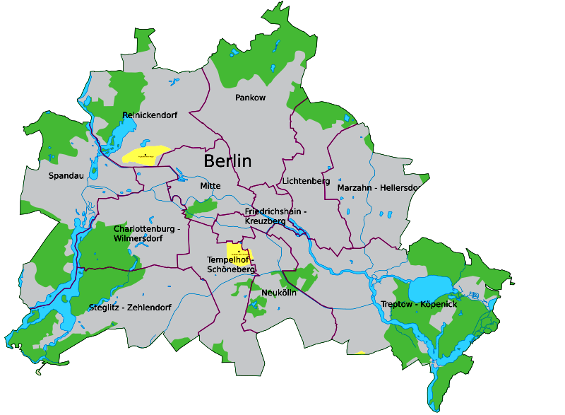
(Fig. 3 : Map of Berlin)

3.4 Data Source: Open-Meteo API historical daily weather data.
DATASET OVERVIEW
The dataset used for this study is open-source data, sourced from Open-Meteo API historical daily weather data. The historical weather data fetched from the Open-Meteo API historical daily weather data contains two years of historical weather data for Berlin-Germany, ranging from June 17, 2024, to June 17, 2026, which is equivalent to 731 days of daily weather information or records.
The Open-Meteo API provides daily weather history information from ERA5. The ERA5 refers to the fifth-generation atmospheric reanalysis dataset produced by the European Centre for Medium-Range weather forecasts. According to Wu and Xue, (2024), ERA5 is designed to supply continuous daily weather data for all regions globally at a spatial resolution of 0.25 degrees since 1940 till date. The API is queried programmatically using Python's requests library. The geographic coordinates used for the Berlin query are latitude 52.5200°N and longitude 13.4050°E, which correspond to the approximate centroid of the Berlin city area. Data are requested at daily temporal resolution, allowing direct retrieval of aggregated daily statistics (daily mean, maximum, and minimum 2-metre air temperature) without the need to manually aggregate hourly records
There exist multiple reasons to choose Open-Meteo in place of paid providers. First, using Open-Meteo does not imply having a subscription account, accessing data through institutions, or requesting API keys, meaning that every researcher equipped with an Internet connection and basic programming skills can easily replicate my methodology regarding data collection. Secondly, it has been shown that ERA5 weather predictions exhibit excellent performance in validating with ground-based measurements throughout Europe and, hence, constitute a highly reliable source for scientific investigations and operational weather prediction services (Xu, Yu, Wang, Chai, and Zhang, 2025). Using a validated reanalysis weather data source helps preclude possible discrepancies in atmospheric phenomena across cities caused exclusively by erroneous or inconsistent weather measurements rather than true variations.
The features collected include Temperature (max, min, mean), Precipitation sum, Wind speed max, Relative humidity (max, min, mean), Shortwave radiation (solar energy), and Evapotranspiration. The dataset fetched comprises 731 rows and 10 columns, split into training (80%) and testing (20%). That is, 560 data sizes are used for training, and 141 data sizes are used for testing. It contains ten (10) numerical variables with seven (7) numerical variables representing (float64) and the remaining three (3) numerical variables as (int64).
The descriptive summary statistics revealed the characteristics of the forecasting zone (Berlin) climate pattern. The daily mean temperature for Berlin is in the range of - 8.70°C during the winter season to +29.75°C at the peak summer season, while the overall daily mean temperature recorded was 10.73°C, with its standard deviation of 7.8°C.
The cyclical temporal features such as ['day_sin', 'day_cos', 'month_sin', 'month_cos'] were added to increase the dimensionality of the data. This approach increased the total features from ten (10) to fourteen (14). Below is the description of the current total features size of the data:
['temp_max', 'temp_min', 'temp_mean', 'precipitation', 'wind_speed_max', 'radiation', 'evapotranspiration', 'humidity_max', 'humidity_min', 'humidity_mean', 'day_sin', 'day_cos', 'month_sin', 'month_cos'].
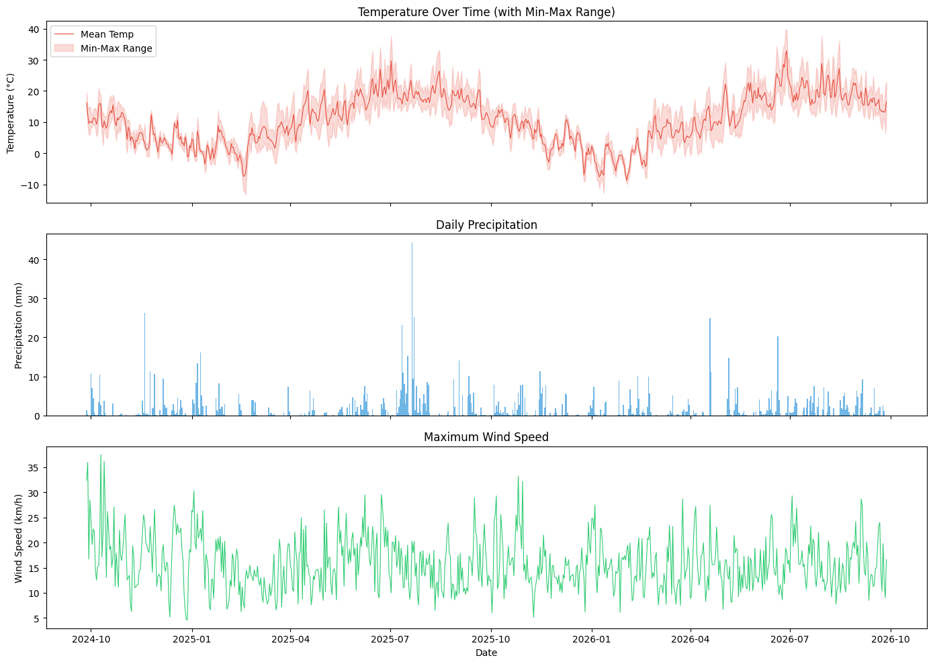
(Fig. 4 : Temperature, Daily Precipitation and Maximum Wind Speed Range w.r.t years)

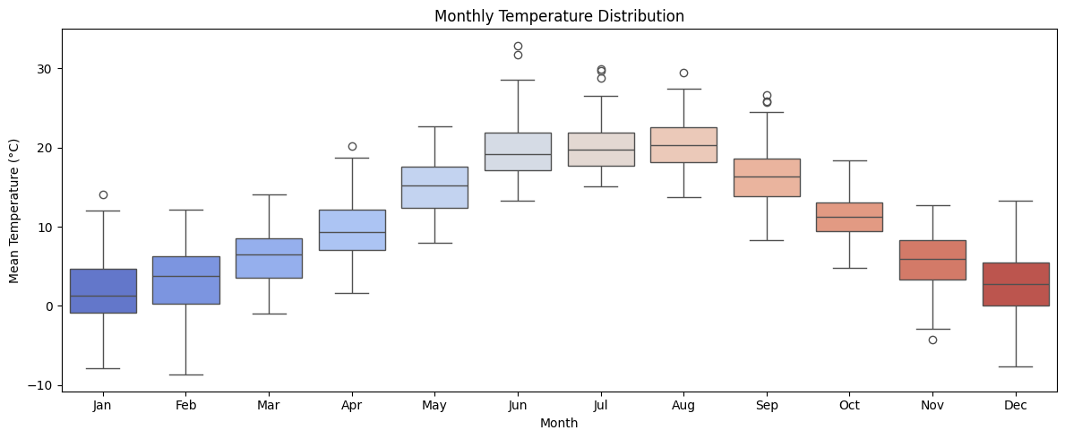
(Fig. 5 : Monthly Distribution of Temprature)
Data insight
The dataset fetched contains ten (10) numerical variables with seven (7) numerical variables representing (float64) and the remaining numerical variables as (int64).
Data Coloums | Data Types
temp_max | float64
temp_min | float64
temp_mean | float64
precipitation | float64
wind_speed_max | float64
radiation | float64
evapotranspiration | float64
humidity_max | int64
humidity_min | int64
humidity_mean | int64

The data shape is (731, 10), implying that the dataset comprises 731 rows and 10 columns.
Data Preprocessing
According to S. Bandgar, (2012), Preprocessing is the practice of cleaning, altering, and reorganizing raw data prior to processing and analysis, which is also known as data preparation. An Aberdeen Group study states that data preprocessing refers to any activity taken in order to improve the quality, usability, accessibility, and portability of data (Jamshed. H. et al., 2019).
This is a critical step that involves transforming raw data into a suitable format for modeling (Kişmiroğlu, C., & Isik, O. 2025).
The Steps used in preprocessing the data include handling of missing values (forward fill + backward fill), normalization of all features using MinMaxScaler and the Splitting of the data into training and testing.
Handling of missing values (forward fill + backward fill): The forward fill and backward fill were used in handling missing values. After data cleaning, no missing values were recorded.
Normalization of features:
According to Anysz et al., (2016) data normalization is an essential work of machine learning. Different input data usually has different dimensions and units. Rojas, (1996) asserts that normalization of data leads the models to faster convergence and minimizes errors during training. The study employed MinMaxScaler, imported from SKlearn.preprocessing library, to normalize the data to ensure that all the features are scaled to a given range. The normalization was done in the range of zero to one (0, 1). The Min and Max constitute the minimum and the maximum values of the entire dataset. This is useful for improving model performance. The MinMaxScaler does not reduce the effect of outliers, but it linearly scales them down into a fixed range where the largest occurring data point corresponds to the maximum value and the smallest value corresponds to the minimum value.
Splitting of dataset:
The dataset is split into two sets. That is training set and test set, where 80% of the dataset was used for training and 20% for testing.
Feature Engineering:
The following are the three key decisions made under this section:
Lookback window (30 days):
The model employs 30-day lookback window. This implies that the following day’s mean temperature is predicted using 30 days previously observed historical weather.
Target variable (temp_mean): The target variable chosen for this forecast is daily mean temperature representing the average temperature recorded over the 24-hour period due to its ability to give constant and representative measure of daily atmospheric patterns as compared to the daily maximum temperature or minimum temperature which are prone to short term variations.
Temporal features: Temporal features including the Day of year and month are encoded as cyclical (sin/cos) features to capture seasonality. The cyclical temporal features such as ['day_sin', 'day_cos', 'month_sin', 'month_cos'] were added to increase the dimensionality of the data. This approach increased the total features from ten (10) to fourteen (14). Below is the description of the current total features size of the data:
['temp_max', 'temp_min', 'temp_mean', 'precipitation', 'wind_speed_max', 'radiation', 'evapotranspiration', 'humidity_max', 'humidity_min', 'humidity_mean', 'day_sin', 'day_cos', 'month_sin', 'month_cos'].
The sequence shape now becomes: X= (701, 30, 14), y = (701,), with Training and Test sets as follows:
Training X_train = (560, 30, 14), y_train = (560,) and Test set: X_test= (141, 30, 14), y_test = (141,), meaning 1 temperature prediction is equivalent to each sample: 30 days × 14 features.
Hyperparameter Tuning
Keras Tuner (Hyperband) is used to systematically search for optimal hyperparameters for both the LSTM and Transformer models.
The hyperparameters tuned used for the Bi-LSTM include the number of LSTM units (Layer 1 & 2), dropout rate, learning rate and dense layer units. Additionally, the Number of attention heads, Feed-forward dimension, Number of encoder blocks, Dropout rate, Learning rate are the tuned hyperparameters used for the Transformer. This replaces manual guessing with principled search, significantly improving model accuracy.
Model Development
The training strategy adopted include Optimizer: Adam (tuned learning rate), Loss: Mean Squared Error (MSE), Early stopping, Learning rate reduction on plateau
Early stopping (with patience=15): Early Stopping callback is employed to halt training when the training loss does not decrease over 15 consecutive epochs to prevent overfitting. Overfitting is where a model performs well on training data and does not perform well on the unseen data (test data).
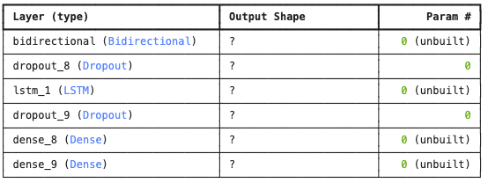
(Fig. 6 : BiLSTM Model Structure)

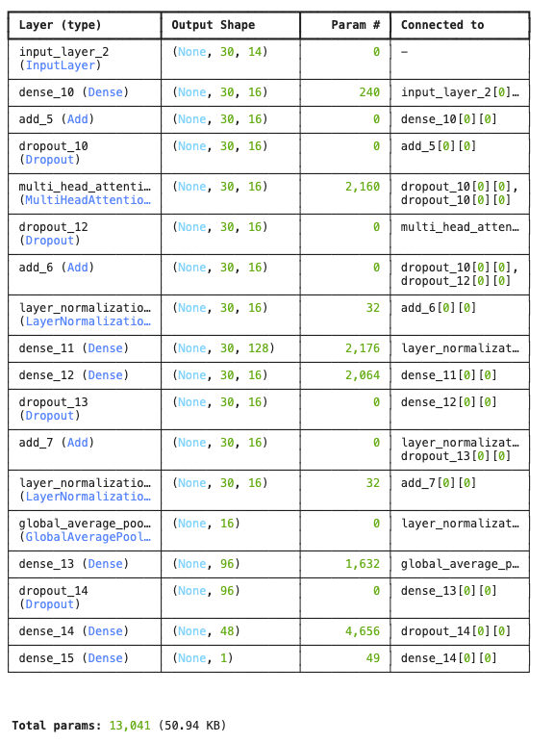
(Fig. 7 : Transformer Model Structure)

Model Evaluation
ETHICAL CONSIDERATIONS
The codes used in this study including data acquisition, preprocessing, model evaluation and training are implemented in Python 3.11, TensorFlow version: 2.21.0, NumPy version: 1.26.4, Pandas version: 2.3.3, Scikit-learn and Seaborn libraries.
The historical weather information used for this project was obtained from the Open-Meteo API which is an open source (free) available online and does not require API key. The Open-Meteo API terms of service permit academic and research use. Additionally, this study will release its full code via GitHub repository to enable researchers to replicate my work.
This research raises no significant ethical concerns. The dataset used for this study freely available data with no personal or sensitive information. That is, no human subjects, animals or vulnerable populations are involved.

CHAPTER 4: RESULTS

4.1 Introduction
This chapter presents the empirical results of the three models used to predict the daily mean temperature for Berlin with geographical coordinate (52.52°N, 13.405°E), Germany including a Bidirectional Long Short-Term Memory (BiLSTM), Transformer, and Facebook Prophet model.
The results are presented in the order in which they were obtained by the experimental pipeline discussed in Chapter three (3). That is, characteristics of dataset, data preprocessing, the results of the hyperparameter tuning, model development and evaluation.

4.2 Data Characteristics
This study uses an Open-Meteo API meteorological dataset, which contains historical daily weather data for the city of Berlin-Germany, spanning from June 17, 2024, to June 17, 2026. The Open-Meteo API supplies daily weather history information that comes from ERA5. The data from this source is free to access, it does not require API key.
The dataset provides daily observations of essential weather parameters, including temperature (temp_max, temp_min, temp_mean), precipitation, wind speed, radiation, evapotranspiration and humidity (humidity_max, humidity_min, humidity_mean). The dataset fetched comprises 731 rows and 10 columns. The dataset is split into training (80%) and testing (20%). That is, 560 data size is used for training, and 141 data size were employed for testing. It contains ten (10) numerical variables with seven (7) numerical variables representing (float64) and the remaining three (3) numerical variables as (int64).
The descriptive summary statistics revealed the characteristic of the forecasting zone (Berlin) climate pattern. The daily mean temperature for Berlin is in the range of - 8.70°C during the winter season to +29.75°C at the peak summer season, while the overall daily mean temperature recorded was 10.73°C, with its standard deviation of 7.8°C.
The cyclical temporal features such as ['day_sin', 'day_cos', 'month_sin', 'month_cos'] were added to increase the dimensionality of the data. This approach increased the total features from ten (10) to fourteen (14). Below is the description of the current total features size of the data after the addition of the cyclical temporal features:
['temp_max', 'temp_min', 'temp_mean', 'precipitation', 'wind_speed_max', 'radiation', 'evapotranspiration', 'humidity_max', 'humidity_min', 'humidity_mean', 'day_sin', 'day_cos', 'month_sin', 'month_cos'].
The Forward fill and Backward fill were employed to handle the missing values. No missing values were recorded after data cleaning which confirms the reliability of the chosen dataset (ERA5) as the source of data for this study.

4.2.1 CORRELATION ANALYSIS
Correlation analysis is a term used to denote the association or relationship between two or more quantitative variables. This analysis is fundamentally based on the assumption of a straight line. The end result of a correlation analysis is a Correlation coefficient whose values range from -1 to +1. A correlation coefficient of +1 indicates that the two variables are perfectly related in a positive [linear] manner, a correlation coefficient of -1 indicates that two variables are perfectly related in a negative [linear] manner, while a correlation coefficient of zero indicates that there is no linear relationship between the two variables being studied (NJ Gogtay and UM Thatte, 2017).
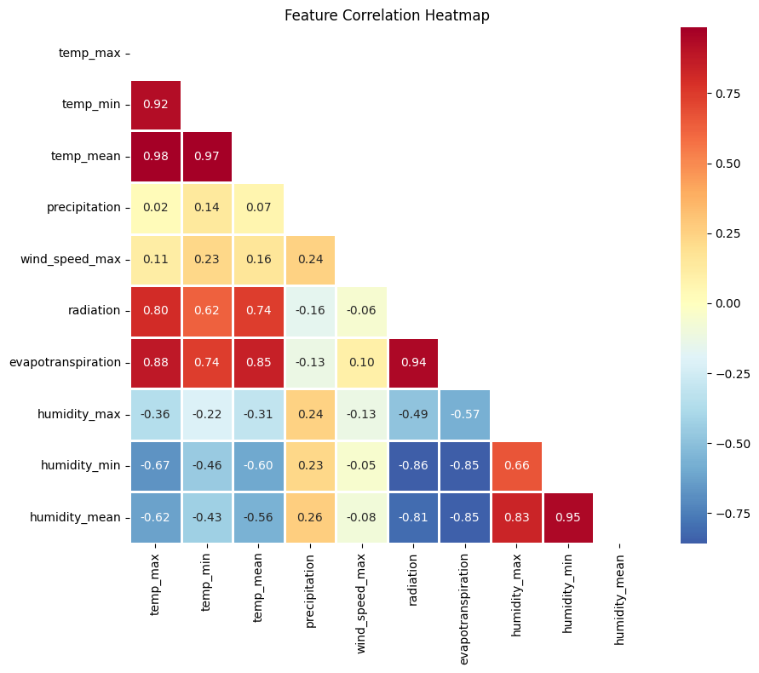
(Fig. 8 : Correlation Matrix)
The correlation analysis above reveals that there is strong multicollinearity among the three temperature variables including maximum temperature (temp_max), minimum temperature (temp_min), and mean temperature (temp_mean) with the temp_mean recording 0.98. Evapotranspiration and radiation displayed strongest positive correlation with temp_mean (r ≈ 0.88) and (r ≈ 0.80) respectively while Precipitation and Wind Speed showed weak positive correction with temperature (r ≈ 0.02) and (r ≈ 0.11). Relative humidity a moderate negative correction with the temperature Mean (r ≈ -0.62).
After applying the cyclical sine/cosine encoding for the Day-of – year and Month, normalization scaling of (0,1), and the splitting of the dataset by 80/20, the training set comprised 560 sequences and the test set 141 sequences, each of shape (30 days × 14 features). No data leakage was detected between the sets.

4.3 HYPERPARAMETER TUNING RESULTS
Hyperparameter tuning plays a crucial role in determining the accuracy and efficiency of Deep Learning models (Asmaa, 2025). To ensure optimal performance, the following hyperparameters were carefully selected:

4.3.1 Bi-LSTM hyperparameter Search
The Keras Tuner (Hyperband) was used to systematically search for the optimal hyperparameters for Bi-LSTM (Bidirectional Long Short-term Memory). The Bi-LSTM first layer ranges from 64 to 256 units while the layer 2 also ranges from 32 to 128 units. Dropout rate is 0.1 to 0.4. The dense layer sizes also range from 16 to 64 units. The learning rates include 0.01, 0.001, 0.0005 and 0.0001. The search ran up to 40 epochs with 15% validation split on the trained data. The validation set was used for hyperparameter tuning. Early stopping was applied at patience = 5 on the validation loss. The best Bi-LSTM hyperparameter obtained after search are displayed in the table below:
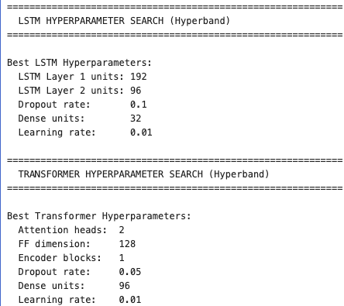
(Fig. 9 : Best Hyper parameters for BiLSTM)

4.3.2. Transformer Hyperparameter Search
The Transformer hyperparameter search was done using the Keras Tuner (Hyperband). This explored the number of attention heads values [2,4, 8], with feed-forward dimension values ranging from 64 (minimum) to 256 (Maximum). Additionally, the number of encoder blocks also ranges from the minimum of 1 to the maximum of 3. The units for the dense rate is from 32 to 128 while the dropout rate is from 0.05 to 0.30. The learning rates include 0.01, 0.001, 0.0005 and 0.0001.
The search also ran up to 40 epochs per configuration, with validation split of 0.15 (15%). The purpose of having the validation set is to have unbiased evaluation of the test set using the final version of the trained model. Early Stopping was employed at patience (5) on the validation loss with a batch size set to 32.
Below is the Table representing the best hyperparameter for Transformer obtained after the search.
(Fig. 10 : Best Hyper parameters for Transformer)

4.3.3 Prophet Hyperparameter search
The Prophet’s hyperparameter search was done using the random approach. The parameters employed for the search include Changepoint Prior Scale, which controls the model’s sensitivity to trend changes, Seasonality Prior Scale, which determines the flexibility of the seasonal component, Seasonality Mode, which specifies whether the seasonal component is treated as addictive or multiplicative (Fadel M. H. A., Wina W., & Gunawan A., 2025), and Changepoint range, which is the proportion of history used for trend changepoints.
The hyperparameter search was done by sampling 20 grid combinations from the full grid of 80 combinations (5*4*2*2). That is, the combination of five (5) default values for Changepoint Prior Scale (0.001, 0.01, 0.05, 0.1, 0.5), four (4) default values for the Seasonality Prior Scale (0.1, 1.0, 5.0, 10.0), two (2) variables for the Seasonality Mode (additive or multiplicative), and two (2) default values for the Changepoint range (0.8 or 0.9), making the full grid of 80.
The best Prophet hyperparameters recorded after search include 0.001 for Changepoint prior scale, 0.1 for the Seasonality prior scale, Multiplicative for the Seasonality mode and 0.8 for Changepoint range. These hyperparameters will be used to train the Prophet model. The best Mean Absolute Error (MAE) obtained was 3.084 °C.
The table below illustrates the top five (5) configurations of Prophet.
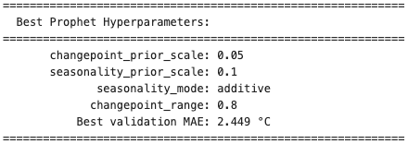
(Fig. 11 : Best Hyperparameters for Prohet Configuration)

4.4 MODEL DEVELOPMENTS
This section discusses the strategies applied in developing the three models proposed for this study including Long Short-Term Memory (Bi-LSTM), Transformer and Facebook Prophet to predict the next 7-days temperature for Berlin, Germany (52.52°N, 13.405°E).

4.4.1 LSTM (Bidirectional) Model Development
The BiLSTM model used for temperature forecasting was built using the Keras library. The model starts with an LSTM layer as the input layer which has 128 units and uses the ReLU activation function. It is set to return sequences for further processing. The input shape is defined based on the shape of the training data. A dropout layer is added after the first LSTM layer. Dropout helps prevent overfitting by randomly disabling a fraction, that is 10% of the neurons during training. The LSTM layer is added as a hidden layer, also with 128 units and the ReLU activation function. However, it does not return sequences, as it is the last hidden layer. A dropout layer is added after the second LSTM layer. The output layer is added as a dense layer with 1 unit, which is responsible for predicting the next value in the sequence. The model is compiled with the Adam optimizer, Mean squared error loss function (MSE) and metrics (MAE). The model is trained for 100 epochs with a batch size of 32. Additionally, a validation split of 0.15 is used, which implies that 15% of the training data is reserved for validation during training. As a result of the experiments, it was seen that the method gave better results with these parameters. The LSTM used 2-3 minutes training time.

4.4.2 Transformer Model Development
The transformer used 30 to 50 minutes of training time.

4.4.3 Prophet Model Development
The Prophet Model serves as a statistical baseline model with automatic seasonality detection. This is a predictive model developed by Facebook specifically for time series data. Prophet adopts an additive modeling framework that combines trend, seasonality, and holiday effects to effectively capture complex temporal patterns. Prophet’s key strength is its ability to adapt automatically to various data structures and incorporation of external regressors when appropriate (Fadel M. H. A., Wina W., & Gunawan A., 2025).
Though Facebook Prophet is an additive regression model that decomposes time series into Trend, Seasonality and Holiday effects. However, this study is limited to only trend and seasonality. The random search approach was employed to perform the Prophet’s hyperparameter search using parameters such as changepoint prior scale, seasonality prior scale, seasonality mode and changepoint range. The best hyperparameters recorded after the search was used for model development. In an effort to improve the accuracy of the model, additional regressors such as humidity, radiation, wind speed, and precipitation were also added. The Prophet model used 30 seconds training time.
MODEL EVALUATION
The model performances are evaluated on the held-out test set using the standard error metrics including Mean Absolute Error (MAE), Mean Absolute Percentage Error (MAPE), Root Mean Squared Error (RMSE), and R² Score (Coefficient of Determination). These metrics are vital for evaluating model accuracy in regression and time-series tasks (A. Botchkarev, 2018). These Metrics are widely used to quantify prediction errors and gauge model fit.
Mean Absolute Error (MAE): This represents the difference between the original and predicted values extracted by averaging the absolute difference in the data set. It calculates how far the predicted values are from the true values and averages the absolute values of these errors. It is a performance metric that is sensitive to the size of errors. The lower the value of the Mean Absolute Error (MAE), the closer the model's predictions are to the true values. The results show that the Mean Absolute Error (MAE) for LSTM is 2.11°C, the Transformer’s Mean Absolute Error recorded is 11.50 °C as well as 3.08 °C for the Prophet model. The results revealed that LSTM had the lowest value of the Mean Absolute Error (MAE), followed by the Prophet model and the Transformer model respectively.
Mean Absolute Percentage Error (MAPE): This is a widely utilized metric in time series forecasting that quantifies the average size of errors between forecasted and real values, represented as a percentage (. A smaller MAPE value signifies a more precise model. The Mean Absolute Percentage Error for the LSTM is 201995252.1, the Transformer also recorded 308521322.61 and the Prophet obtained 104224356.45.
Root Mean Squared Error (RMSE): Is the square root of the mean squared error, that is, the MSE. It is an evaluation metric that shows how far the predicted values are from the observed values. The LSTM once again had the lowest RMSE of 2.68 °C, with Prophet and Transformer recording 3.80 °C and 14.66 °C in that order.
The R² score, also known as the coefficient of determination, indicates how well the predicted values of a model capture the variance in the actual data. An R² value of 1 means the model perfectly explains all the variability in the target variable, representing ideal predictive performance. An R² of 0 implies that the model fails to explain any variance and performs no better than simply predicting the mean of the observed data (Sevgin, 2025). If the R² score is negative, it suggests that the model performs worse than a naive mean predictor. In general, a desirable R² score ranges between 0 and 1, with values closer to 1 indicating stronger explanatory power and more reliable predictions (Setiawan, Elwirehardja, & Pardamean, 2022).
The LSTM obtained a R² Score of 0.8497, the Prophet recorded 0.6985 and the Transformer also achieved R² Score of -3.4906. This implies that Transformer model performs worse compared to LSTM and Facebook Prophet.
The table below shows a comparison of the evaluation results for the three models.
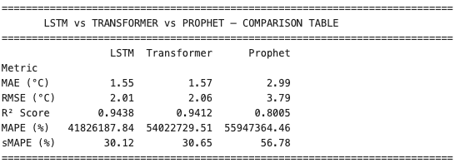

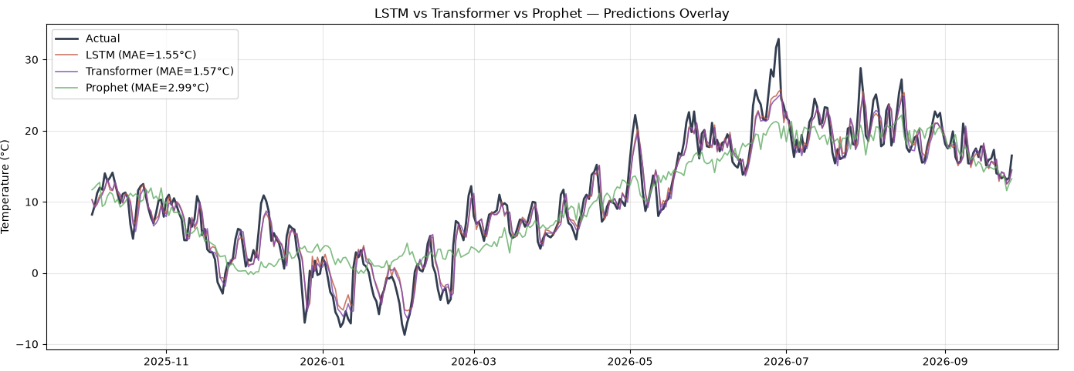
(Fig. 12 : Final Comparision among all three models)

In comparing the above results, it is evident that LSTM won 3 out of the 4 metrics including MAE, RMSE and R² Score making it the overall best model, followed by Prophet which won 1 out of the 4 metrics that is the Mean Absolute Percentage Error (MAPE %) with the Transformer recording 0 out of the 4 metrics.

REFERENCES
- Al-Selwi, S.M., Hassan, M.F., Abdulkadir, S.J., Muneer, A., 2023. LSTM inefficiency in long-term dependencies regression problems. J. Adv. Res. Appl. Sci. Eng. Technol. 30, 1631. http://dx.doi.org/10.37934/araset.30.3.1631
- Bonn, B., von Schneidemesser, E., Andrich, D., Quedenau, J., Gerwig, H., Lüdecke, A., Kura, J., Pietsch, A., Ehlers, C., Klemp, D., Kofahl, C., Nothard, R., Kerschbaumer, A., Junkermann, W., Grote, R., Pohl, T., Weber, K., Lode, B., Schönberger, P., Churkina, G., Butler, T. M., & Lawrence, M. G. (2016). BAERLIN2014—The influence of land surface types on and the horizontal heterogeneity of air pollutant levels in Berlin. Atmospheric Chemistry and Physics, 16(12), 7785–7811. https://doi.org/10.5194/acp-16-7785-2016
- D. Fister, J. P´erez-Aracil, C. Pel´aez-Rodríguez, J. Del Ser, and S. Salcedo-Sanz, “Accurate Long-Term Air Temperature Prediction with Machine Learning Models and Data Reduction Techniques,” Applied Soft Computing 136 (2023): 110118, https://doi.org/10.1016/j.asoc.2023.110118
- Sardans, J., et al., Warming and Drought Alter Soil Phosphatase Activity and Soil P Availability in a Mediterranean Shrubland, Plant Soil, 289 (2006), 1-2, pp. 227-238
- Dugord, P.-A., Lauf, S., Schuster, C., & Kleinschmit, B. (2014). Land use patterns, temperature distribution, and potential heat stress risk. The case study Berlin, Germany. Computers, Environment and Urban Systems, 48, 86–98. https://doi.org/10.1016/j.compenvurbsys.2014.07.005
- Kabisch, N., & Haase, D. (2014). Green justice or just green? Provision of urban green spaces in Berlin, Germany, landscape and urban planning, 122, 129–139. https://doi.org/10.1016/j.landurbplan.2013.11.016
- Kottek, M., J. Grieser, C. Beck, B. Rudolf, F. Rubel, 2006: World Map of the Köppen-Geiger climate classification updated. – Meteorol. Z. 15, 259–263. DOI:10.1127/ 0941-2948/2006/0130.
- Langer, I., Schartner, T., Billing, H., & Cubasch, U. (2010). Vegetationsänderung in Berlin-Brandenburg. Ein Vergleich von Satellitendaten und einem regionalen Klimamodell. (Diskussionspapier 9). Retrieved from urn:nbn:de:kobv:b4-opus-17585
- Ozbek, A.; Sekertekin, A.; Bilgili, M.; Arslan, N. Prediction of 10-min, hourly, and daily atmospheric air temperature: Comparison of LSTM, ANFIS-FCM, and ARMA. Arab. J. Geosci. 2021, 14, 622. [Google Scholar] [CrossRef]
- Malakouti, S. M., Utilizing Time Series Data From 1961 To 2019 Recorded Around the World and Machine Learning to Create a Global Temperature Change Prediction Model, Case Stud. Chem. Environ. Eng., 7 (2023), June, 100312
- Tran, T. T. K., et al., Increasing Neurons or Deepening Layers in Forecasting Maximum Temperature Time Series?, Atmosphere (Basel)., 11 (2020), 10, 1072
- Abhishek, K., et al., Weather Forecasting Model Using Artificial Neural Network, Procedia Technol., 4 (2012), Dec., pp. 311-318
- Qiu, R., et al., River Water Temperature Forecasting Using a Deep Learning Method, J. Hydrol., 595 (2021), Apr., 126016
- Zhengxin, L., Yue, Z., Application of Fuzzy Control Based on Time Series Prediction Algorithm in Main Steam Temperature System, Proceedings, Chinese Automation Congress (CAC), Xi'an, China, 2018, Nov., pp. 116-121
- Wei, K., Du, M., A Temperature Prediction Method of IGBT Based on Time Series Analysis, Proceedings, The 2nd International Conference on Computer and Automation Engineering (ICCAE), Singapore, 2010, pp. 154-157
- Zhang, W. Y., et al., Single-Step and Multi-Step Time Series Prediction for Urban Temperature Based on LSTM Model of TensorFlow, Proceedings, 2021 Photonics & Electromagnetics Research Symposium (PIERS), Hangzhou, China, 2021, pp. 1531-1535
- Kreuzer, D.; Munz, M.; Schlüter, S. Short-term temperature forecasts using a convolutional neural network — An application to different weather stations in Germany. Mach. Learn. with Appl. 2020, 2, 100007. [Google Scholar] [CrossRef]
- Lee, S.; Lee, Y.S.; Son, Y. Forecasting daily temperatures with different time interval data using deep neural networks. Appl. Sci. 2020, 10, 1609. [Google Scholar] [CrossRef]
- S. Bandgar, Data Preparation in Data Science. Analytics Vidhya. https://medium.com/analytics-vidhya/data-preparation-in-data-science-16f9311760. Accessed 17 March 2022
- H. Jamshed, M.S.A. Khan, M. Khurram, S. Inayatullah, S. Athar, Data preprocessing: A preliminary step for web data mining. 3C Tecnología_Glosas de innovación aplicadas a la pyme 8(1), 206–221 (2019)
- NJ Gogtay and UM Thatte. Statistics for Researchers: Principles of Correlation Analysis. Journal of The Association of Physicians of India. Vol. 65. March (2017)
- Kişmiroğlu, C., & Isik, O. (2025). Temperature Prediction Using Transformer–LSTM Deep Learning Models and Sarimax from a Signal Processing Perspective. Applied Sciences, 15(17), 9372. https://doi.org/10.3390/app15179372
- Ozbek, A.; Sekertekin, A.; Bilgili, M.; Arslan, N. Prediction of 10-min, hourly, and daily atmospheric air temperature: Comparison of LSTM, ANFIS-FCM, and ARMA. Arab. J. Geosci. 2021, 14, 622. [Google Scholar] [CrossRef]
- [16]. Reichstein, M.; Camps-Valls, G.; Stevens, B.; Jung, M.; Denzler, J.; Carvalhais, N.; Prabhat, F. Deep learning and process understanding for data-driven Earth system science. Nature 2019, 566, 195–204. [CrossRef] [PubMed]
- Atamimi, F. M. H., Witanti, W. and Abdillah, G. (2025) “Enhanching Prophet Time Series Forecasting on Sparse Data via Hyperparameter Optimizattion: A Case Study in Retail”, Sinkron : jurnal dan penelitian teknik informatika, 9(2), pp. 1000-1007. doi: 10.33395/sinkron.v9i2.14804.
- 21. Zhang,J.; Wang,B.; Hua, M.; Chen, Z.; Liang, S.; Kang, X. Spatiotemporal Meteorological Prediction Based on Fully Convolutional Neural Network. IEEE Trans. Geosci. Remote Sens. 2024, 62, 4107818. [CrossRef]
- Ma, C., Yan, C., Suo, Q., & Liu, C. (2022). Meteorological data combination prediction model based on Prophet + LSTM.
- J., Jagannathan & C, Divya. (2021). Time Series Analyzation and Prediction of Climate using Enhanced Multivariate Prophet. International Journal of Engineering Trends and Technology.
- Jaydip, S., Sidra, M., 2022. Long-and-short-term memory (LSTM) networks architectures and applications in stock price prediction. In: Emerging Computing Paradigms: Principles, Advances and Applications. Wiley, pp. 143–160. http://dx.doi.org/10. 1002/9781119813439.ch8.
- Toharudin, T. et al. (2023) ‘Employing long short-term memory and Facebook prophet model in air temperature forecasting’, Communications in Statistics - Simulation and Computation, 52(2), pp. 279–290. doi: 10.1080/03610918.2020.1854302
- Toharudin, Toni & Pontoh, Resa & Caraka, Rezzy & Zahroh, Solichatus & Lee, Youngjo & Chen, Rung-Ching. (2021). Employing Long Short-Term Memory and Facebook Prophet Model in Air Temperature Forecasting.
- Al Mansoori, Afra Nasser; Al Ajami, Fatima Ahmed; and Mousa, Maha Ali, "A Hybrid Time-Series PV Power Forecasting Model Implementing Facebook Prophet and Neural Prophet Algorithms" (2022). Thesis. Rochester Institute of Technology.
- Botchkarev, “Performance Metrics (Error Measures) in Machine Learning Regression, Forecasting and Prognostics: Properties and Typology,” Interdisciplinary Journal of Information, Knowledge, and Management 13 (2018): 45–79, https://doi.org/10.28945/4184.
- Asmaa M. E., 2025, An Adaptive Transformer Model for Long-Term Time-Series Forecasting of Temperature and Radiation in Photovoltaic Energy Generation’, Applied Computational Intelligence and Soft Computing. Wiley, Volume 2025, pp. 1 – 19. doi.org/10.1155/acis/6671565
- Fadel M. H. A., Wina W., & Gunawan A., (2025) ‘Enhancing Prophet Time Series Forecasting on Sparse Data via Hyperparameter Optimizattion: A Case Study in Retail’, Sinkron : Journal dan Penelitian Teknik Informatika Volume 9, Number 2, April 2025 DOI : https://doi.org/10.33395/sinkron.v9i2.14804
- Sevgin, F. Machine Learning-Based Temperature Forecasting for sustainable climate change adaptation and mitigation. Sustainability 2025, 17, 1812. [Google Scholar] [CrossRef] [Scilit]
- Setiawan, K.E.; Elwirehardja, G.N.; Pardamean, B. Sequence to sequence deep learning architecture for forecasting temperature and humidity inside closed space. In Proceedings of the 2022 10th International Conference on Cyber and IT Service Management, Yogyakarta, Indonesia, 20–21 September 2022; IEEE: New York, NY, USA, 2022; pp. 1–7. [Google Scholar] [CrossRef] [Scilit]
- Zhang, K., Huo, X., & Shao, K. (2023). Temperature Time Series Prediction Model Based on Time Series Decomposition and Bi-LSTM Network. Mathematics, 11(9), 2060. https://doi.org/10.3390/math11092060

